In this case you’re responsible for developing a real-case web application to handle RESTful API using Laravel 8.0 framework to be consumed by front-end engineers / other parties. Consider this as a condition for a membership subscription business logic which can be accessed from various devices. **This is microservice which mean everything is conducted in RESTful API**:

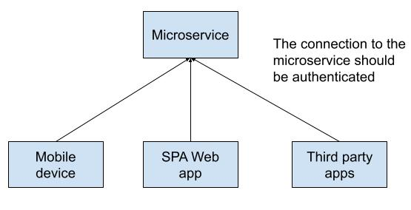

1. Please create an API endpoint to register for a new user by providing email & password.
2. Given the condition please create a RESTful API CRUD process for a table as follow for **each unique authenticated user**:

|  |  |  |
| --- | --- | --- |
| **Column name** | **Data type** | **Description** |
| user_id | auto-increment | Belongs to user table |
| status | Varchar 255 | Value is “active” or “inactive” |
| position | Varchar 255 |  |

1. How to make sure other programmers know how to use your microservice? Please develop a way to allow other engineers / parties to understand how to use the API you have developed.

**Answer:**

I using Swagger UI inside Laravel 8 as API Documentatin It is help programmer which read my API on Browser. Programmer/enginners should understand my api on Browser. We can access on <http://{Laravel API URL> }/api/documentation. You can se my Swager on my Github

1. **Security & proper business logic are critical.** Please develop with proper security & best-practice in mind for your microservice solution design.

* Please put your work in your GitHub account and set it to public so we're able to review it. Good luck!